/

### Real-Life Examples

### Cornell === clue + notes + sum

Understand the theory

Blog Articles

Book

Pls include latest questions and ans

/

----------------------------------------------------------------------------------------------------------------------------------------

## What is HTML?

https://imgs.search.brave.com/dSh1UQLpXpeB1KkwtJcg2_UH9TNuRpkzNkK5A9TMFiE/rs:fit:860:0:0/g:ce/aHR0cHM6Ly90aGVt/ZWNoYW5pY2FsZW5n/aW5lZXJpbmcuY29t/L3dwLWNvbnRlbnQv/dXBsb2Fkcy8yMDIy/LzA4L0RpZmZlcmVu/dC1QYXJ0cy1vZi1D/YXItTmFtZS5wbmc

HTML stands for [HyperText Markup Language](https://www.interviewbit.com/html-cheat-sheet/).

It is one of the crucial language of the web. It is responsible for the structure the content on the webpage eg p , heading , img , audio , video , forms etc.

There are two main components in HTML language, Tags and Attributes.

Example of a car Engine , skeleton etc.

The latest version of HTML is HTML5. The below image shows some basic HTML tags and attributes.

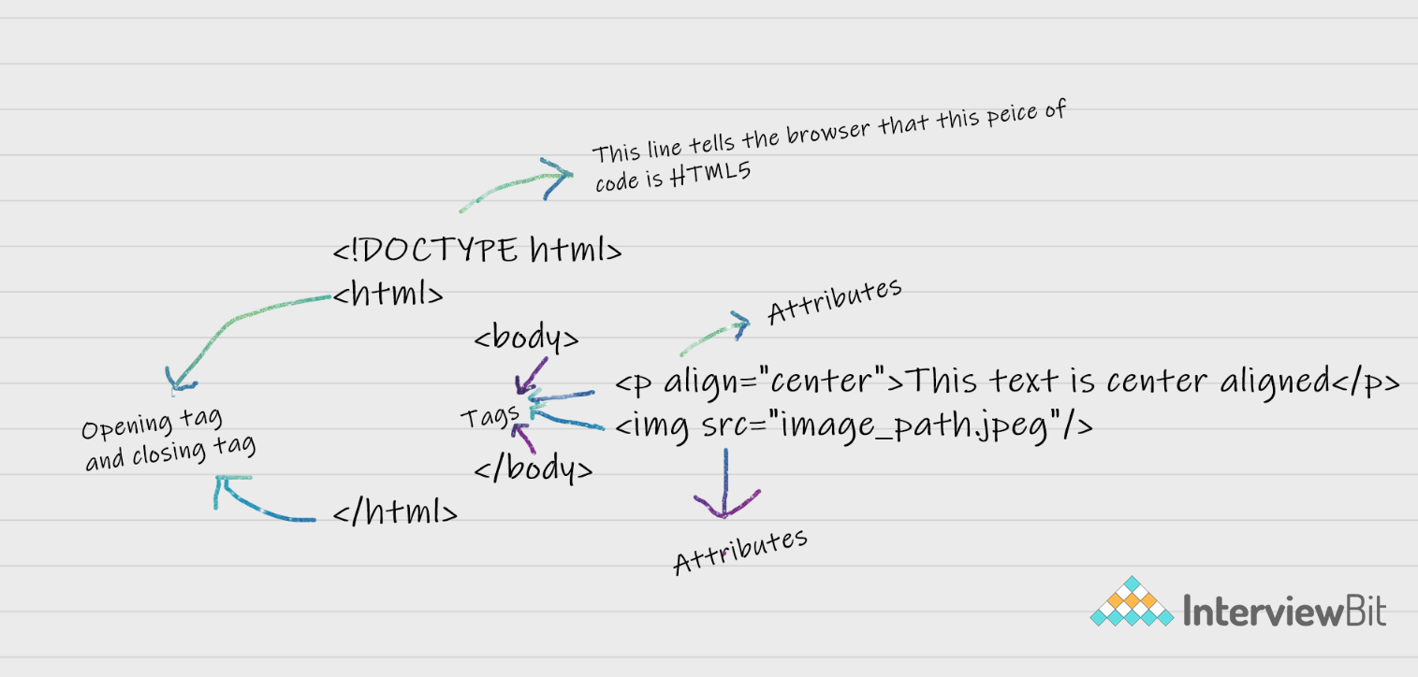

## HTML Interview Questions and Answers

### 1. Are the HTML tags and elements the same thing?

No.

HTML elements are defined by a starting tag, may contain some content and a closing tag.

For example, <h1>Heading 1</h1> is a HTML element but just <h1> is a starting tag and </h1> is a closing tag.

Tags are keywords that browser understands.

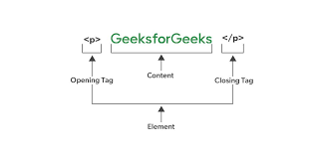

### 2. What are tags and attributes in HTML?

Tags are the primary component of the HTML that defines how the content will be structured/ formatted,

whereas Attributes are used along with the HTML tags to define the characteristics , properties of the element.

Ex Img src

### 3. What are void elements(Self closing) in HTML?

HTML elements which do not have closing tags or do not need to be closed are Void elements. For Example <br />, <img />, <hr />, etc.

4. What is the advantage of collapsing white space?

this helps a developer to indent lines of text without worrying about multiple spaces and maintain readability and understandability of HTML codes.

HTML mein "collapsing white space" ka matlab hota hai ki agar kai saare spaces, tabs, ya newlines ek ke baad ek aate hain toh wo sirf ek hi space ke barabar consider kiye jaate hain.

Isse aap apne HTML code ko achhe se format kar sakte hain bina actual webpage ke layout ko affect kiye.

### 5. What are HTML Entities?

In HTML some characters are reserved like ‘<’, ‘>’, ‘/’, etc.

To use these characters in our webpage we need to use the character entities called HTML Entities.

Below are a few mapping between the reserved character and its respective entity character to be used.

| **Character** | **Entity Name** | **Entity Number** |
| --- | --- | --- |
| < | &lt; | &#60; |
| > | &gt; | &#62; |
| & | &amp; | &#38; |
| (non-breaking space) Eg. 10  PM | &nbsp; Eg. <p>10&nbsp&nbspPM</p> | &#160; |

HTML Entities ka istemal karte hain jab hum kuch special characters ko HTML code mein include karna chahte hain jo nahi directly type kiye ja sakte hain.

Jaise ki <, >, &, ©, etc.

Inko hum HTML entities ke roop mein use karte hain taki wo sahi tareeke se render ho sake web page par.

For example,

agar aap < sign ko directly HTML code mein likhna chahte hain toh aapko use **&lt;** ki jagah likhna padega. Isi tarah se > ke liye **&gt;**, & ke liye **&amp;** ka istemal hota hai.

### 6. What are different types of lists in HTML?

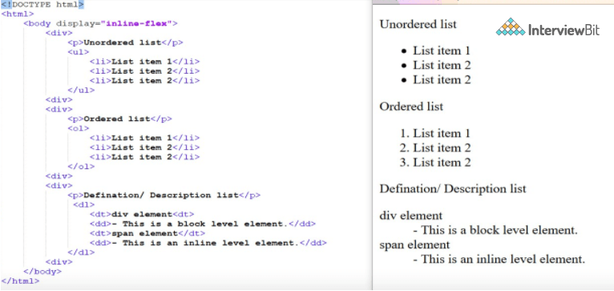

HTML mein alag-alag tarah ke lists hote hain. Sabse common types hain:

1. **Ordered List (OL)**: Isme har item ko number ya koi aur order diya jata hai, jaise 1, 2, 3 ya phir roman numerals (I, II, III).
2. **Unordered List (UL)**: Isme har item ke samne koi specific order nahi hota hai. Ye usually bullets ya dots ke saath dikhaya jaata hai.
3. **Definition List (DL)**: Isme terms aur unke definitions ko display kiya jaata hai. Term ke liye **<dt>** tag aur definition ke liye **<dd>** tag ka istemal hota hai.

Yeh alag-alag types ke lists HTML mein use kiye jaate hain taki content ko visually organized kiya ja sake.

Dt = definition term

Dd = definition desc

Dl = definition list

<dl>

<dt>

Insprational Websites

</dt>

<dd>

It is defined as the websites are made using

</dd>

</dl>

<dl>

<dt>Codedamn</dt>

<dd>An interactive and AI powered coding platform with 200+ coding courses.</dd>

<dt>OpenAI</dt>

<dd>An artificial intelligence research laboratory consisting of the for-profit corporation OpenAI LP and its parent company, the non-profit OpenAI Inc.</dd>

</dl>

### 7. What is the ‘class’ attribute in HTML?

The class attribute is used to specify the class name for an HTML element.

Also, it is mainly used to associate the styles written in the stylesheet with the HTML elements.

Multiple elements in HTML can have the same class value.

8. What is the difference between the ‘id’ attribute and the ‘class’ attribute of HTML elements?

Multiple elements in HTML can have the same class value, whereas a value of id attribute of one element cannot be associated with another HTML element.

1. **ID**: **id** attribute ek single element ko uniquely identify karne ke liye istemal hota hai. Har **id** value ek page mein unique hona chahiye, matlab kisi do elements ka same **id** nahi ho sakta. Ye tab istemal hota hai jab ek hi element ko style karna ho ya fir JavaScript se manipulate karna ho.
2. **Class**: **class** attribute ek group of elements ko define karne ke liye istemal hota hai jo similar characteristics ya styles share karte hain. Ek se zyada elements ek hi class ka member ho sakte hain, aur ek single element multiple classes bhi rakh sakta hai. Ye commonly CSS rules ke liye multiple elements ko style karne ya fir JavaScript se group of elements ko select aur manipulate karne ke liye istemal hota hai.

Q) what is http ?

Ans : request-response protocol designed for transmitting media documents . for communication between web browser and webserver. It follows client server model. Stateless protocol = server never stores any info about client.

q) https vs http

<https://www.google.com/url?sa=i&url=https%3A%2F%2Fwww.boardinfinity.com%2Fblog%2Fhttp-and-https-differences%2F&psig=AOvVaw297zjfTG74sIwfOgCNwH2U&ust=1707219580976000&source=images&cd=vfe&opi=89978449&ved=0CBMQjRxqFwoTCPCBo9eOlIQDFQAAAAAdAAAAABBV>

ans : secure , ssl certificate + encrypted , secure socket layer is a protocol that is used to ensure security on internet . its scrambled in an unreadable format and the kicker gets a meaningless data. It apply various encryption aligorithms.

q) in which order html css js load on the client ?

The Moment we press enter , we intiate the html parser to work.

With the help example

the execution flow is about as follows:

1. The HTML document gets downloaded
2. The parsing of the HTML document starts
3. HTML Parsing reaches <script src="jquery.js" ...
4. jquery.js is downloaded and parsed
5. HTML parsing reaches <script src="abc.js" ...
6. abc.js is downloaded, parsed and run
7. HTML parsing reaches <link href="abc.css" ...
8. abc.css is downloaded and parsed
9. HTML parsing reaches <style>...</style>
10. Internal CSS rules are parsed and defined
11. HTML parsing reaches <script>...</script>
12. Internal Javascript is parsed and run
13. HTML Parsing reaches <img src="abc.jpg" ...
14. abc.jpg is downloaded and displayed
15. HTML Parsing reaches <script src="kkk.js" ...
16. kkk.js is downloaded, parsed and run
17. Parsing of HTML document ends

Q) Semantic Tags in html

A semantic element clearly describes its meaning to both the browser and the developer.

Examples of **non-semantic** elements: <div> and <span> - Tells nothing about its content.

Examples of **semantic** elements: <form>, <table>, and <article> - Clearly defines its content.

<https://www.w3schools.com/html/img_sem_elements.gif>

header will repeat as it sames in the picture.

Nav

Q) what is the difference between div and span tag ?

https://qph.cf2.quoracdn.net/main-qimg-c61df4914345f35fb7bc85214d163760

q) Block vs inline

<https://pbs.twimg.com/media/EdOQGgTXgAE5QdB.jpg:large>

q) what is specificity in css ?

When two (or more) CSS rules refer to the same element, the browser determines which rule relates more to that element (is more specific) and applies that rule. To calculate the specificity of a rule, browsers give IDs a score of 100, classes a score of 10, and HTML selectors a score of 1.

See video in 5 mins